**Thiruvalluvar university**

**Periyar ARTS COLLEGE**

**cuddalore – 607001.**



**DEPARTMENT OF COMPUTER APPLICATIONS**

**MACHINE LEARNING WITH PYTHON**

**Project Title :** Early Prediction For Chronic Kidney Disease Detection: A Progressive Approach To Health Management

**Team Id :** NM2023TMID24249

**Team Leader :** VISHWA M(**8416744BC7C94FF9E88482D3A4A4531F**)

**Team member :** SATHISH K(**D1424B2E05BFEBBAC7A4FB1F9DE9B10E**)

**Team member :** NAVEEN KUMAR S(**643D22BF5BCABB69D904E2859EB5323E**)

**Team member :** MARIYAPRAKASH A(**D3DBDA46AF610CCB5404FC4F2D1298D0**)

INTRODUCTION

overview

Chronic kidney disease (CKD) is a serious and progressive condition that affects millions of people worldwide. It can lead to a range of complications, including heart disease, stroke, and kidney failure. Early detection and management of CKD are crucial to prevent these complications and improve outcomes for patients.

In recent years, there has been increasing interest in using machine learning and other advanced technologies to help predict and detect CKD at an early stage. This approach offers the potential to improve the accuracy of CKD diagnosis, as well as to identify patients who are at high risk of developing the disease.

This paper explores a progressive approach to health management using machine learning for early prediction of CKD. We discuss the current state of CKD diagnosis and management, the potential benefits of early detection, and the challenges of implementing machine learning in healthcare. We also review recent advances in machine learning techniques for CKD detection and discuss the potential implications for clinical practice.

Overall, this paper aims to highlight the importance of early prediction for CKD detection and the potential benefits of a progressive approach to health management using machine learning. By leveraging these advanced technologies, we may be able to improve outcomes for patients with CKD and ultimately reduce the burden of this debilitating disease."

Purpose

The purpose of using early prediction for chronic kidney disease detection is to identify individuals who are at risk of developing kidney disease before they exhibit any symptoms. By detecting the disease in its early stages, healthcare providers can intervene with appropriate treatment and lifestyle modifications to slow or even stop the progression of the disease.

The progressive approach to health management involves using advanced technologies, such as machine learning algorithms and artificial intelligence, to analyze large amounts of data and identify patterns that can help predict the likelihood of an individual developing kidney disease. This approach can help healthcare providers make more informed decisions about treatment options and provide personalized care to their patients.

By detecting chronic kidney disease early, healthcare providers can also prevent complications and reduce the risk of developing other serious health conditions, such as heart disease, stroke, and high blood pressure. Early detection and intervention can improve outcomes and quality of life for individuals with kidney disease."

Advantages

Early Detection: Early prediction for chronic kidney disease (CKD) can help detect the disease at its early stages, when treatment is most effective. This can lead to better outcomes and a higher quality of life for patients.

Improved Management: A progressive approach to health management for CKD patients can help healthcare providers better manage the disease and prevent complications. By monitoring the progression of the disease over time, healthcare providers can adjust treatment plans and medications as needed to help patients maintain their kidney function.

Reduced Costs: Early detection and management of CKD can reduce healthcare costs associated with the disease. This can include hospitalizations, dialysis, and other expensive treatments that may be required if the disease is not detected and managed early.

Better Patient Education: A progressive approach to health management for CKD can help educate patients about their condition and how to manage it. This can lead to better adherence to treatment plans and a better understanding of how lifestyle changes can help slow the progression of the disease.

Disadvantages

False Positives: Early prediction for CKD can result in false positive results, which can lead to unnecessary testing and treatment.

Misdiagnosis: Early prediction can also result in misdiagnosis, which can lead to unnecessary treatment or delay in the treatment of other underlying conditions.

Cost: Implementing an early prediction program for CKD can be expensive, especially in resource-limited settings.

Privacy Concerns: Collecting and analyzing personal health information for early prediction can raise privacy concerns for patients. Healthcare providers must ensure that patient data is collected and stored securely and that patients are informed about how their data will be used."

Applications

Early prediction for chronic kidney disease (CKD) can have numerous applications in health management. Here are some of them:

Timely intervention: Early prediction of CKD can help doctors intervene early and provide appropriate treatment to slow down the progression of the disease. This can help prevent kidney failure and the need for dialysis or transplantation.

Personalized treatment plans: With early prediction, doctors can personalize treatment plans based on the patient's risk factors and medical history. This can improve the effectiveness of treatment and reduce the risk of complications.

Improved patient outcomes: Early detection and intervention can lead to better patient outcomes, including improved quality of life and reduced healthcare costs.

Prevention of comorbidities: CKD is often associated with other health conditions such as cardiovascular disease and diabetes. Early prediction and intervention can help prevent the development of these comorbidities.

Population health management: Early prediction can also help with population health management by identifying high-risk individuals and implementing preventative measures.

Overall, early prediction for CKD can lead to better health outcomes, reduce healthcare costs, and improve population health management.

Conclusion

Conclusion for Early Prediction for Chronic Kidney Disease Detection: A Progressive Approach to Health Management

In conclusion, early prediction for chronic kidney disease (CKD) can play a crucial role in health management. It can help doctors intervene early, provide personalized treatment plans, improve patient outcomes, prevent comorbidities, and aid in population health management. With the help of advanced technologies and predictive analytics, healthcare providers can identify high-risk individuals and take preventative measures to slow down the progression of CKD. Early detection and intervention can not only improve the quality of life of patients with CKD but also have a significant impact on reducing healthcare costs and improving overall population health. Therefore, it is essential to prioritize the development and implementation of progressive approaches to detect and manage CKD at an early stage.

Future scope

Early prediction for chronic kidney disease (CKD) detection has a significant future scope in health management. The approach involves using advanced technology such as artificial intelligence, machine learning, and data analytics to identify patients at high risk of developing CKD.

With the increasing incidence of CKD worldwide, early prediction and diagnosis can help prevent the progression of the disease, reduce the burden on healthcare systems, and improve patient outcomes. Moreover, early prediction can enable healthcare professionals to develop personalized treatment plans for patients, leading to improved quality of life and reduced healthcare costs.

One potential future direction for early prediction for CKD is the development of more accurate and precise predictive models that incorporate multiple data sources, including clinical and genetic data, environmental factors, and lifestyle factors. These models could be used to identify patients at risk of developing CKD and enable healthcare professionals to provide early intervention and treatment.

Another future direction is the integration of mobile health technologies and wearable devices into early prediction and management of CKD. These technologies could be used to monitor and track patient health data in real-time, allowing for early detection of CKD and personalized management of the disease.

In summary, early prediction for CKD detection has immense potential in health management. With further research and development, this approach could lead to improved patient outcomes and reduced healthcare costs, making it a critical area of focus in healthcare.

**Brainstorm**:

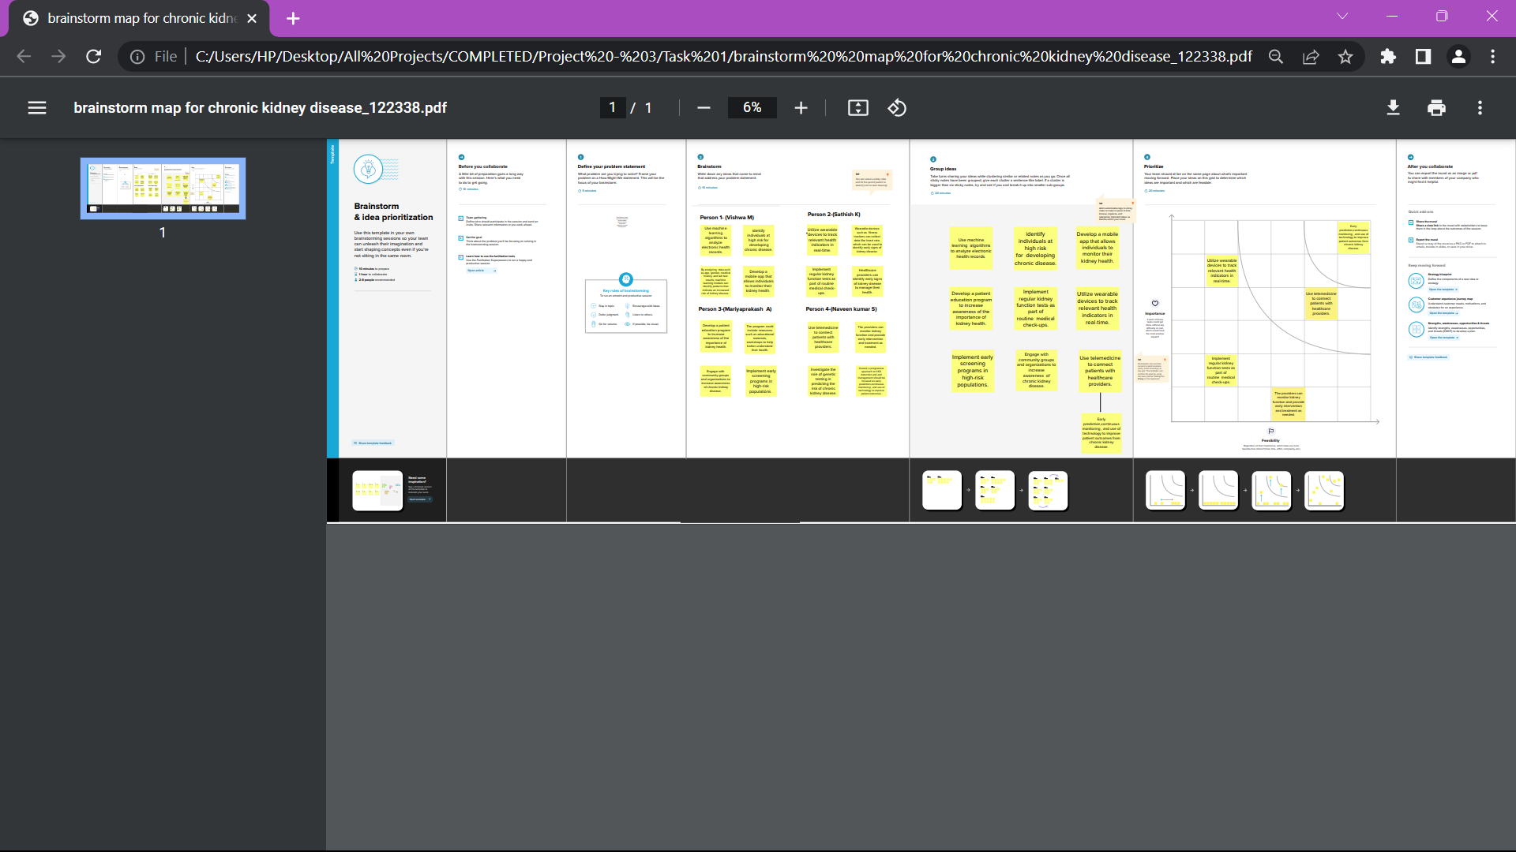

**Empathy Map**:

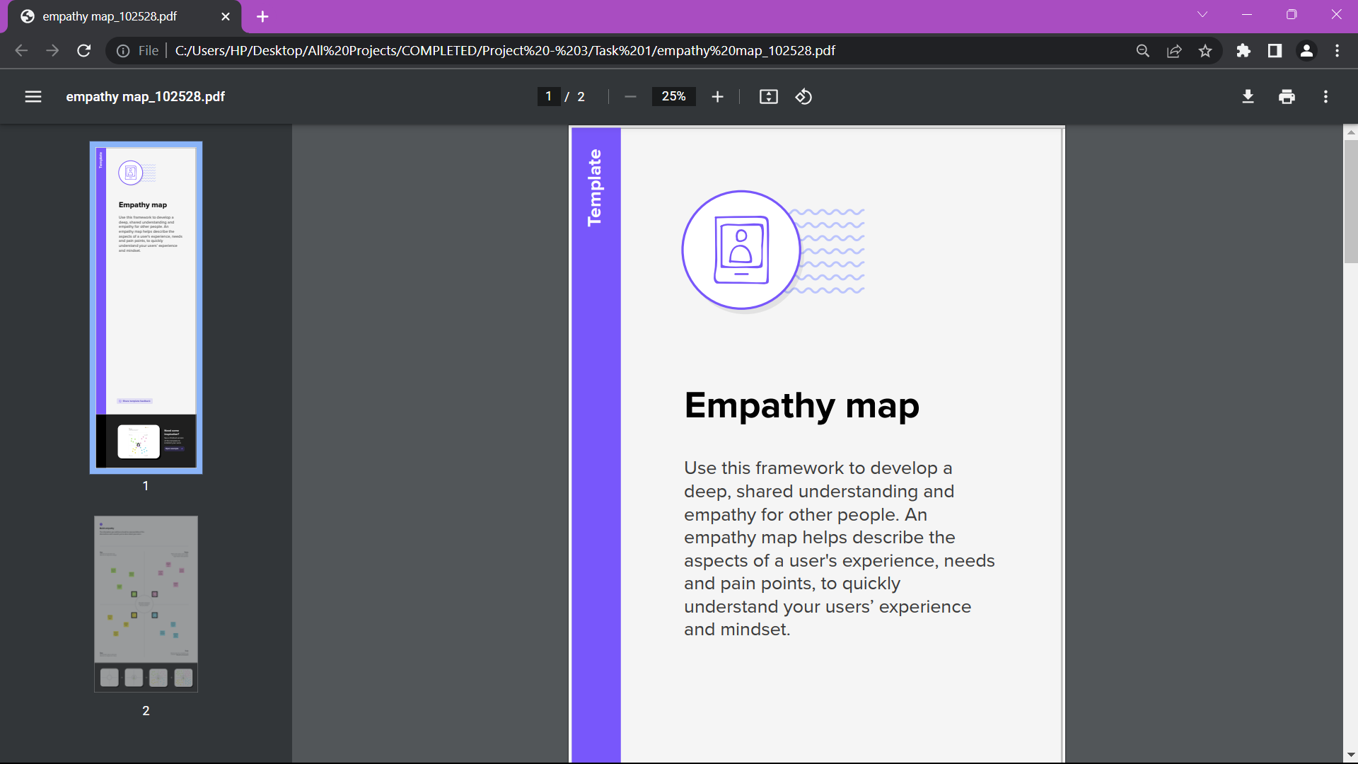

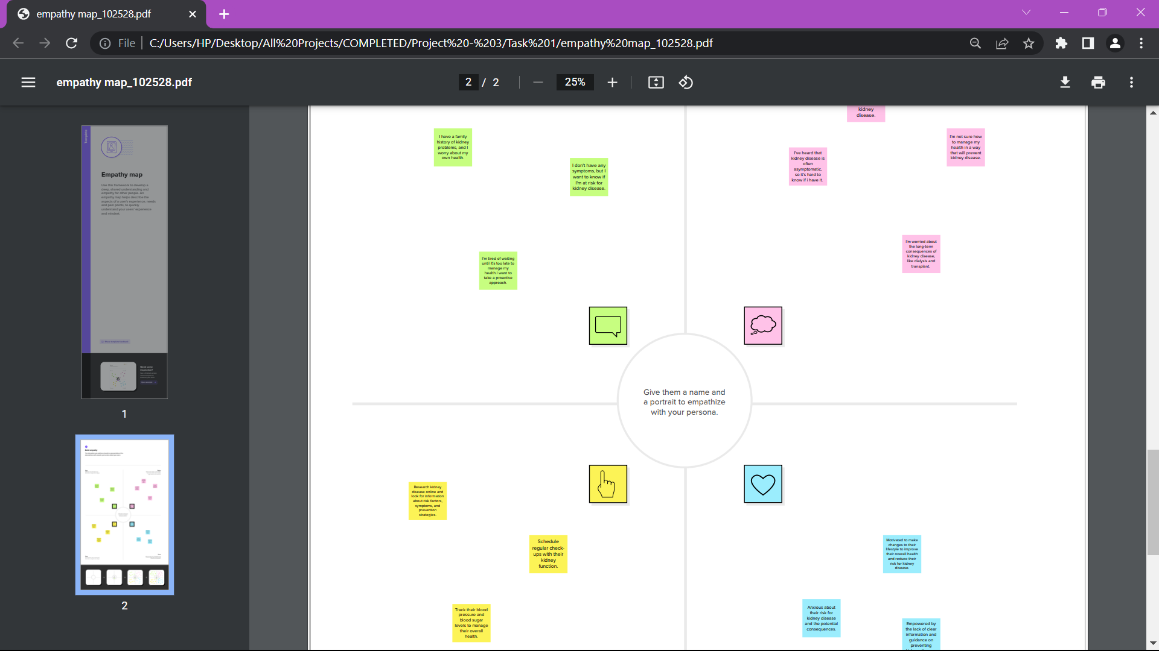

OutPuts:

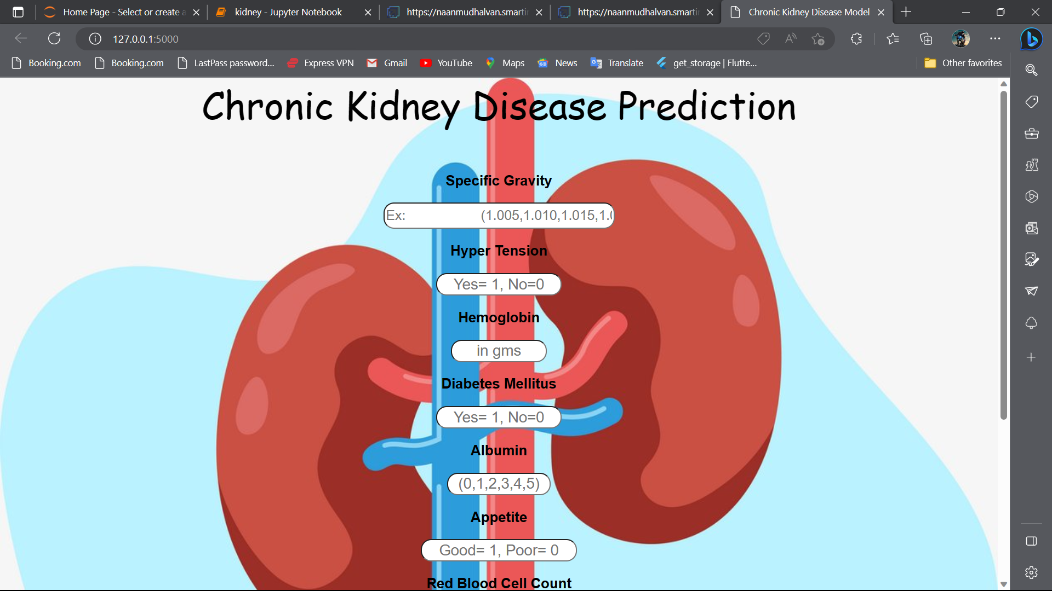

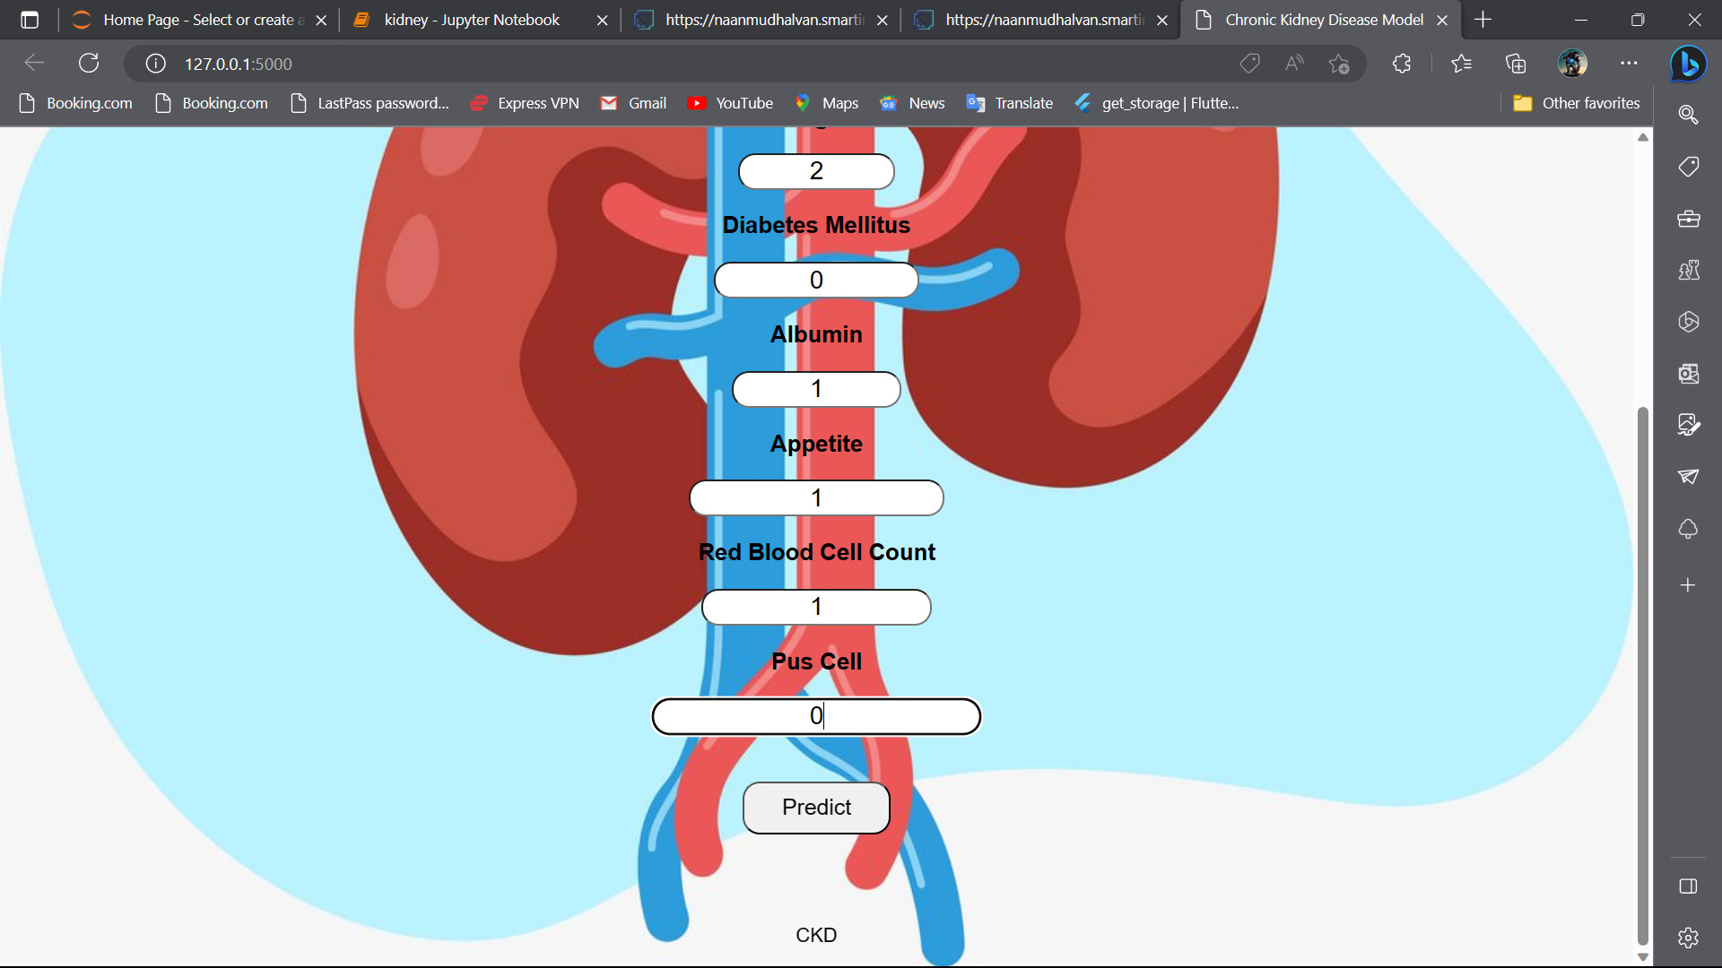

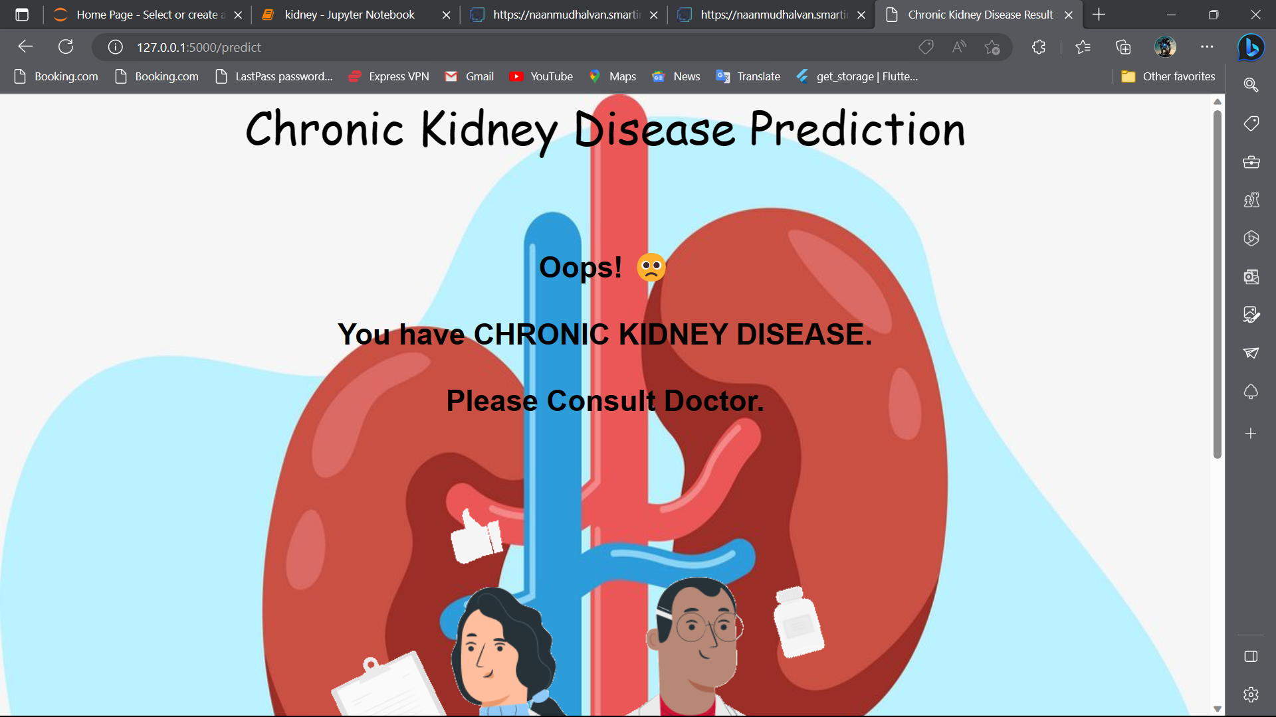

Appendix

Source Code:

kidney.ipynb

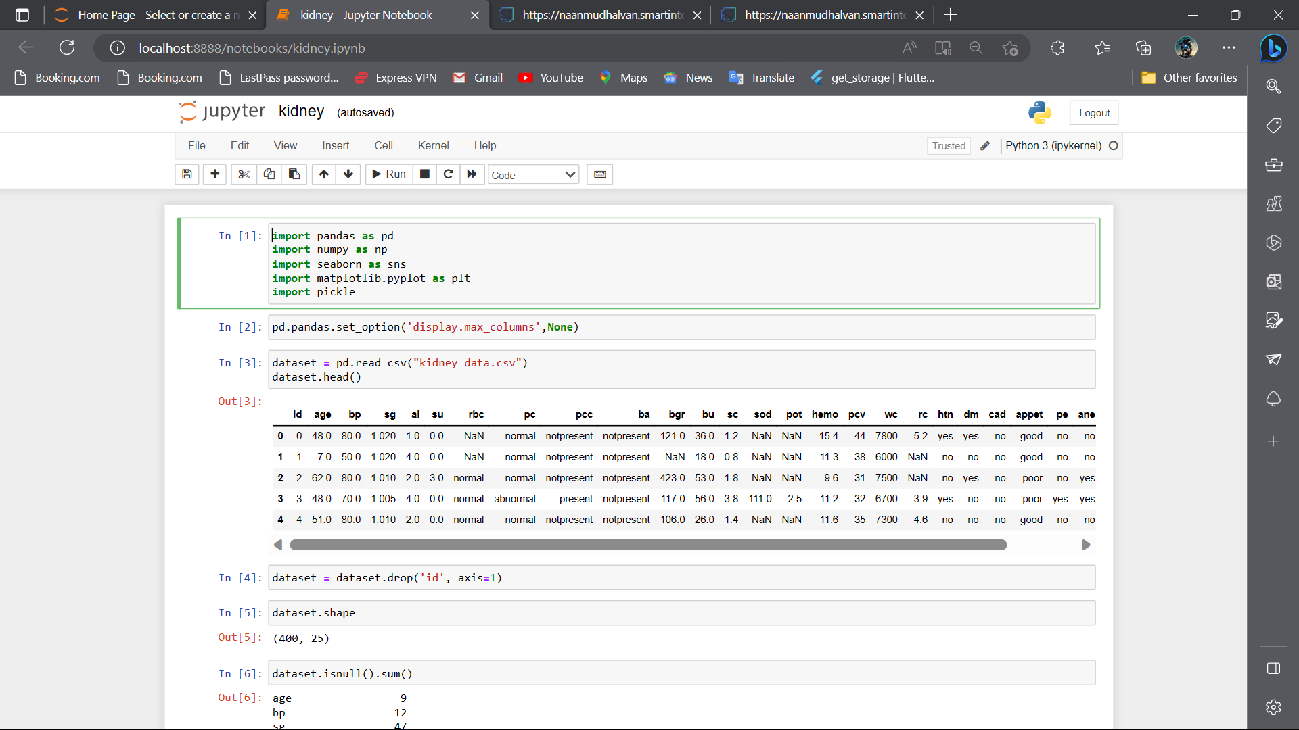

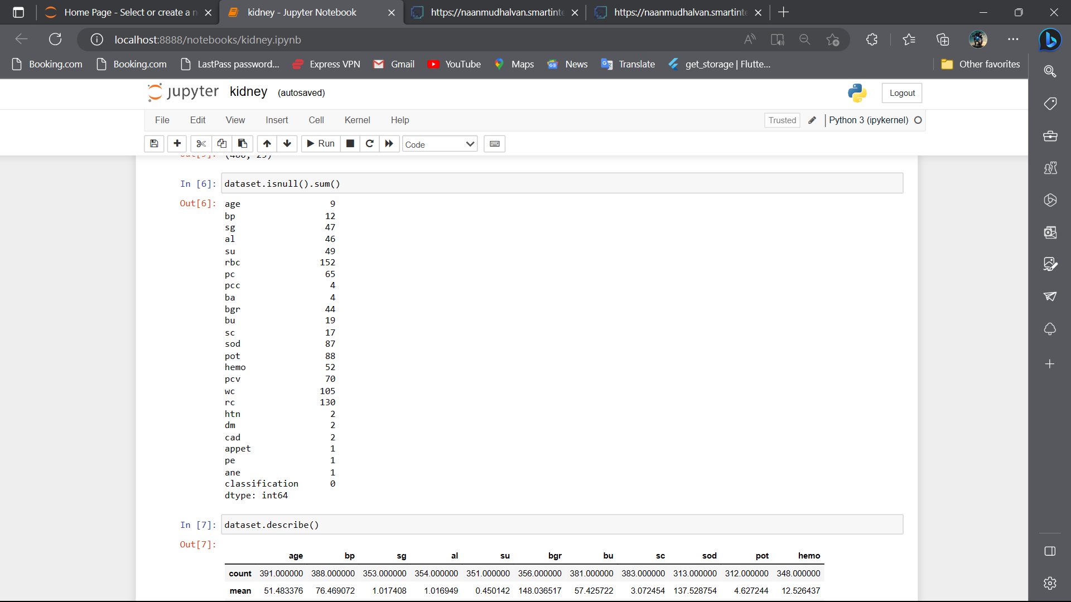

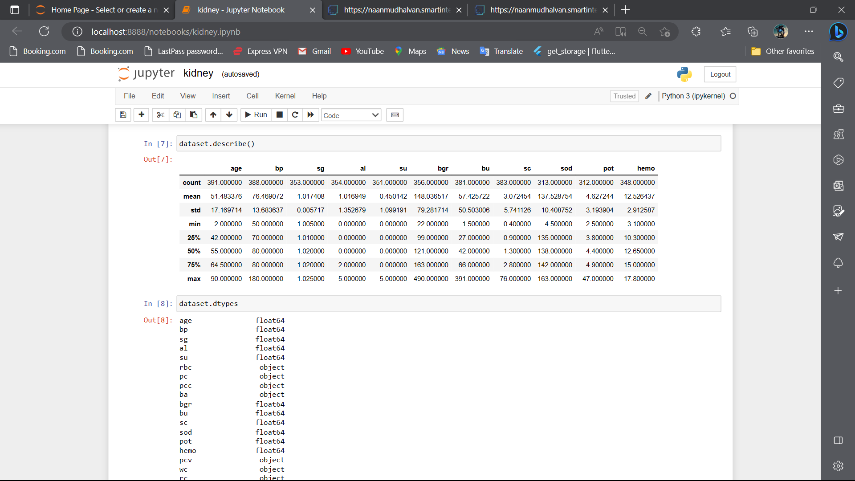

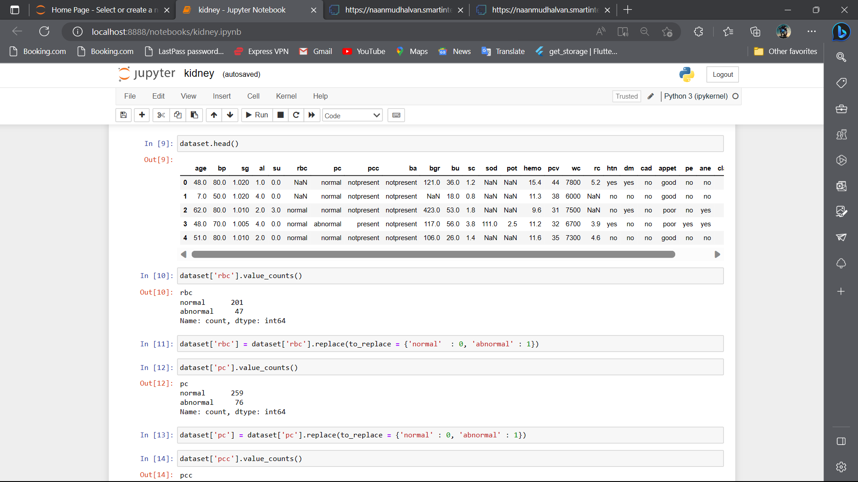

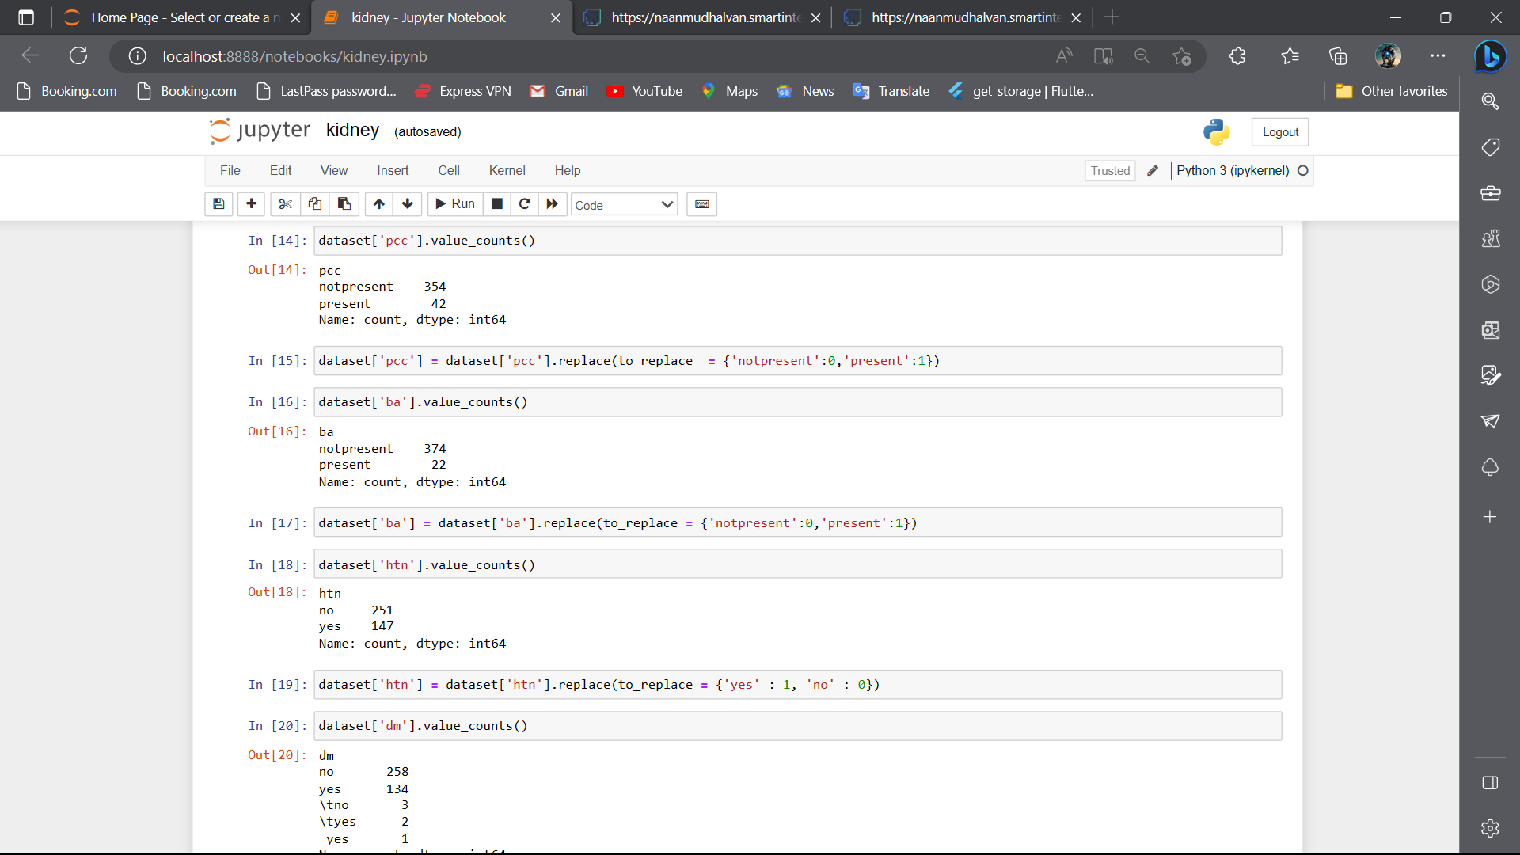

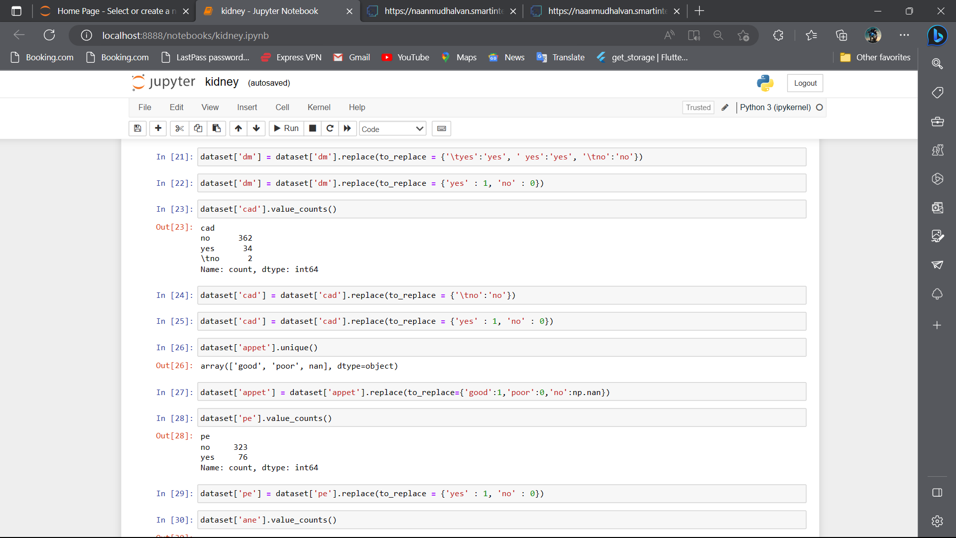

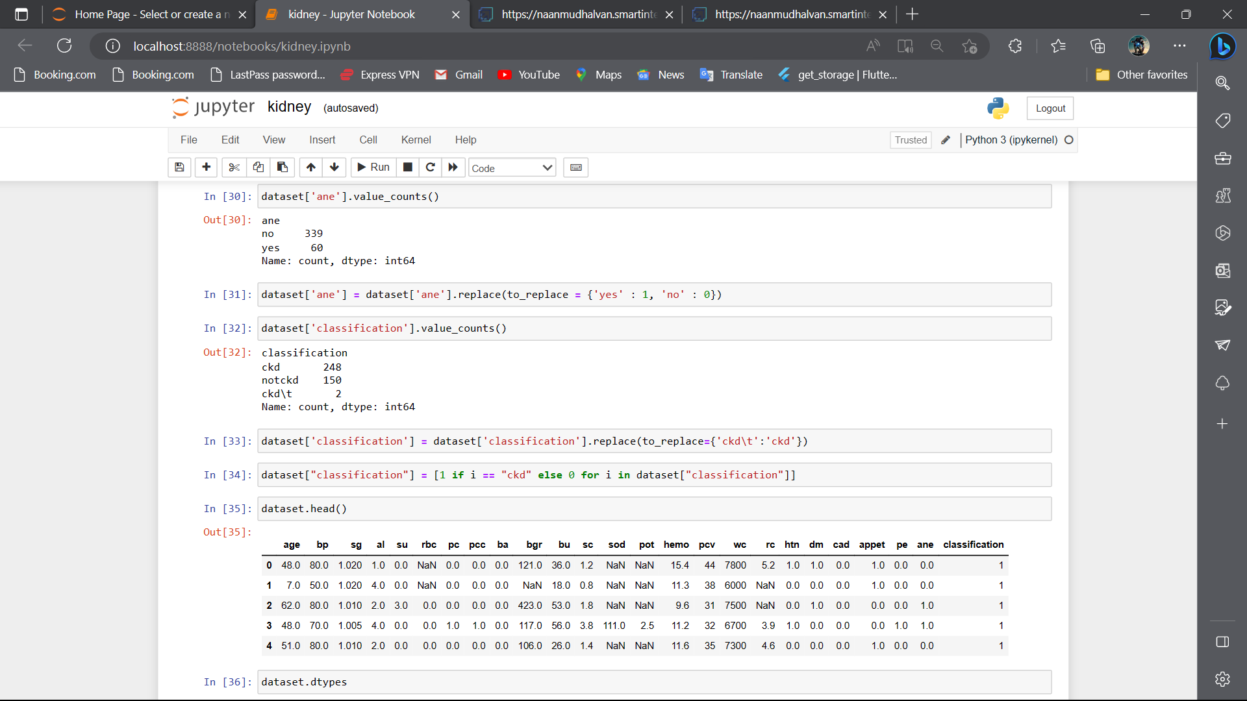

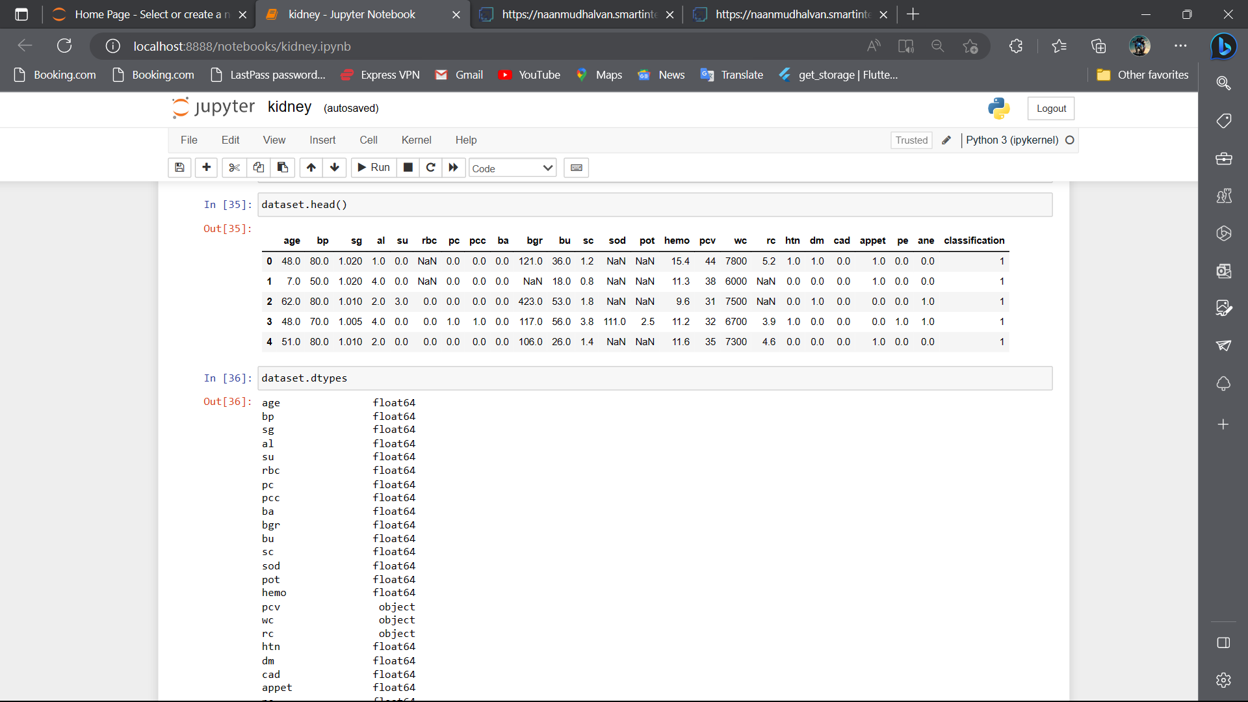

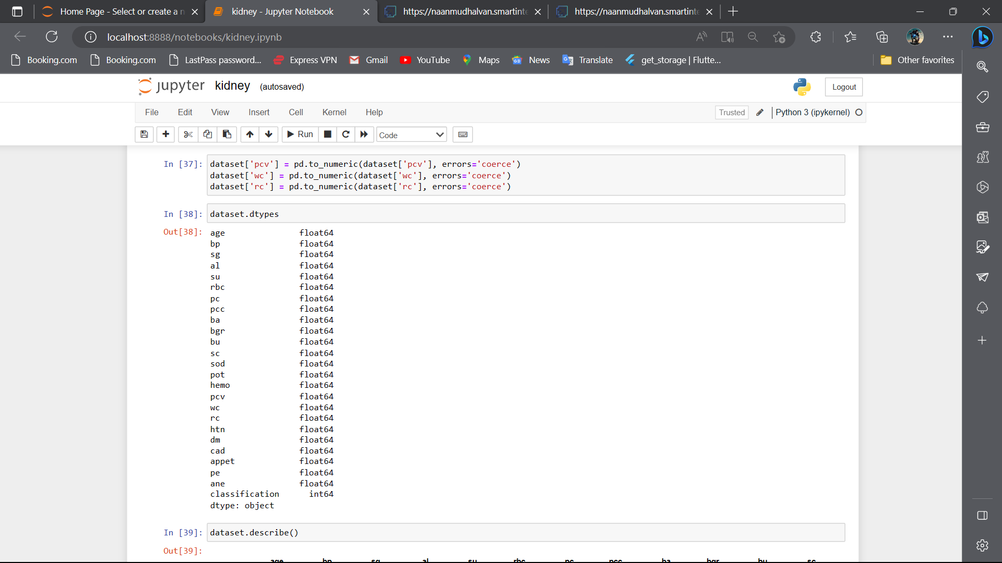

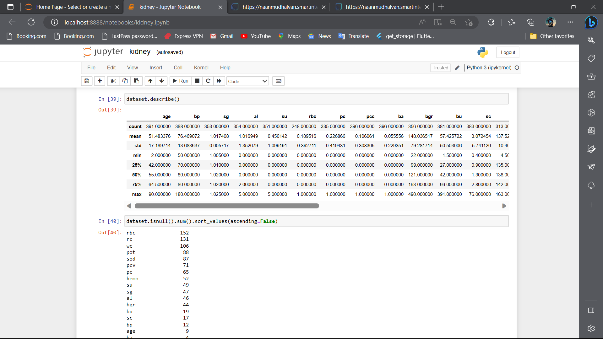

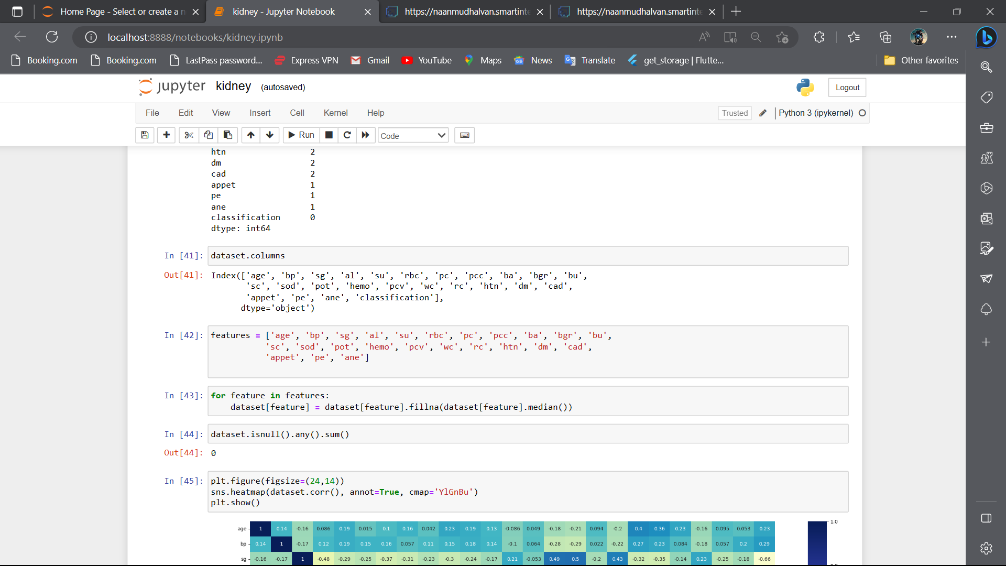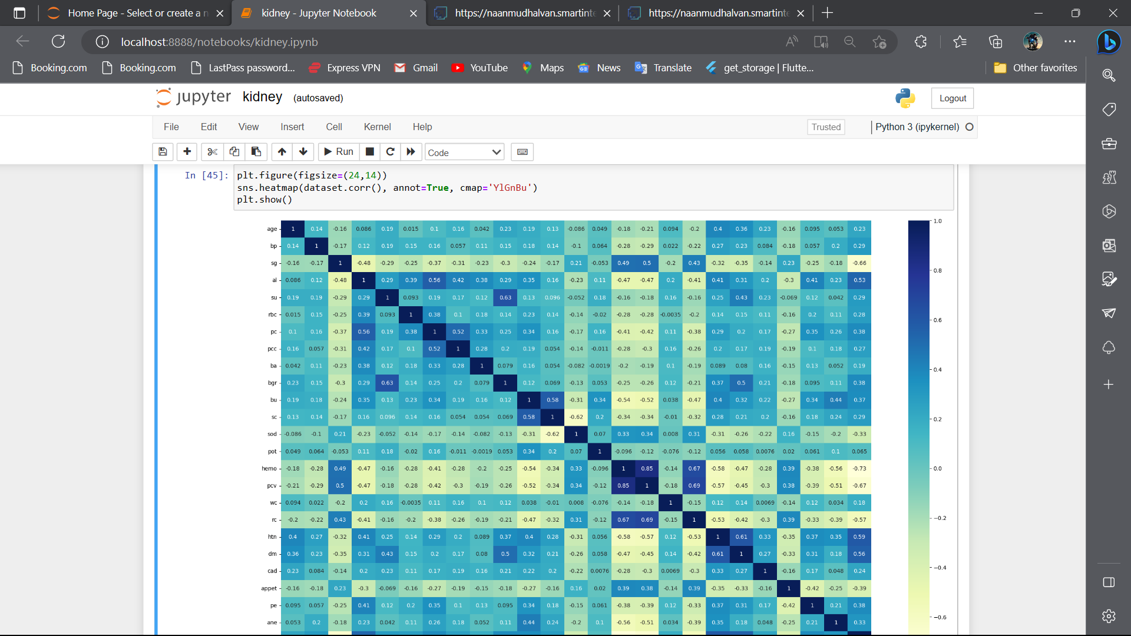

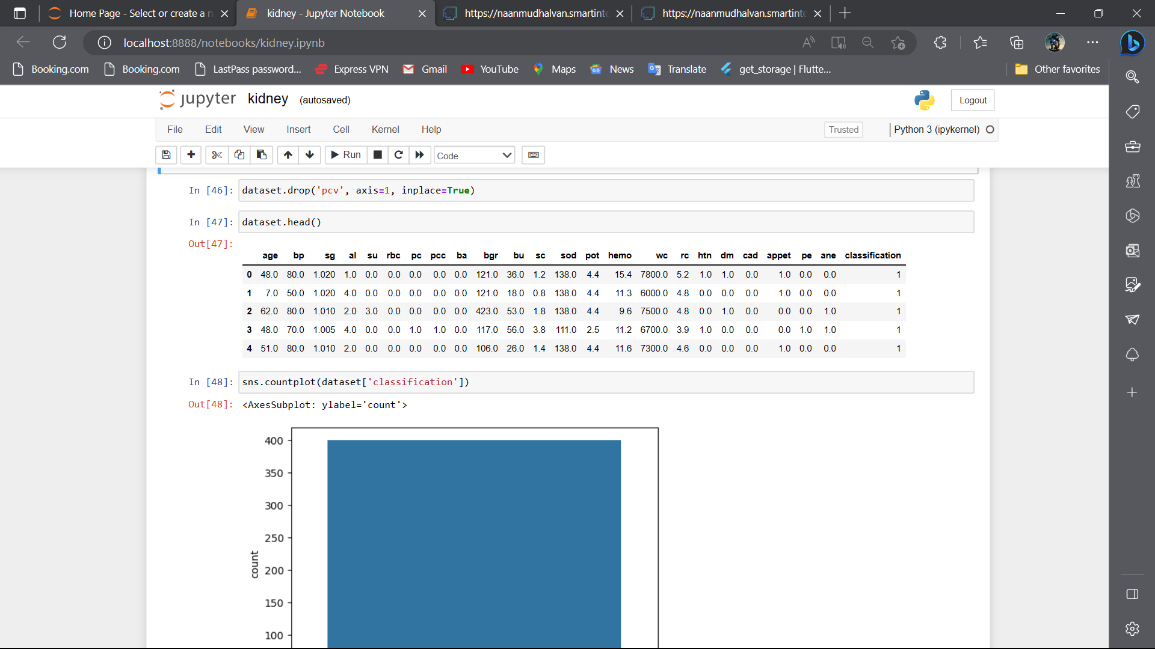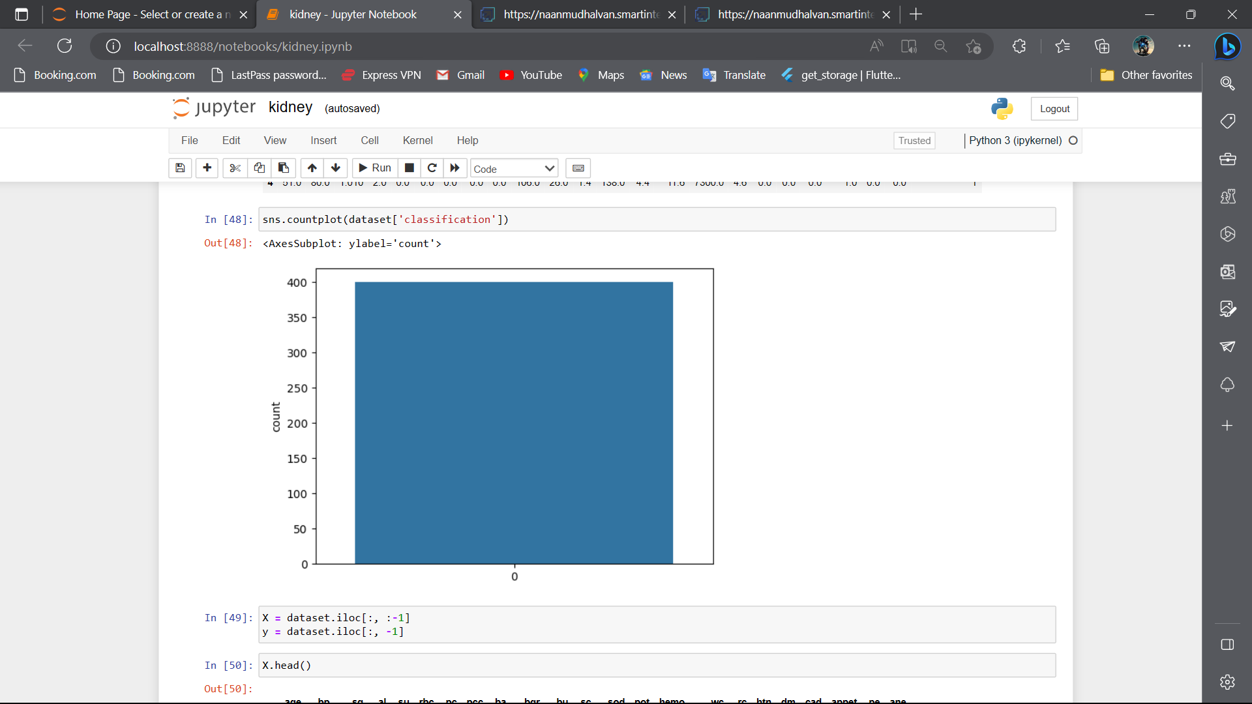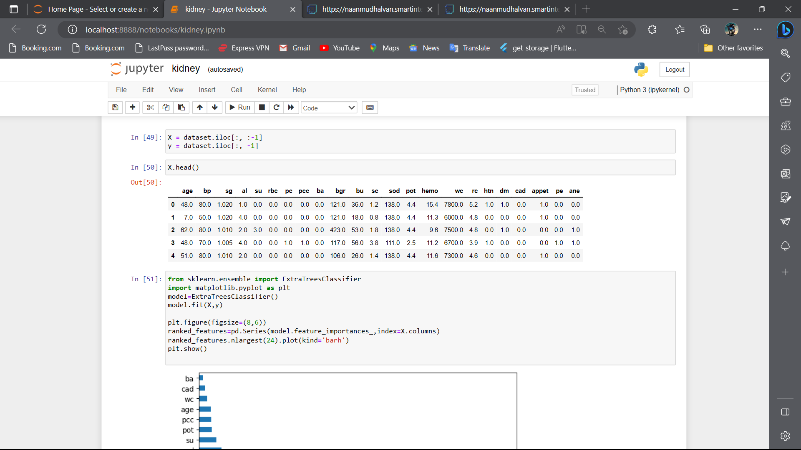

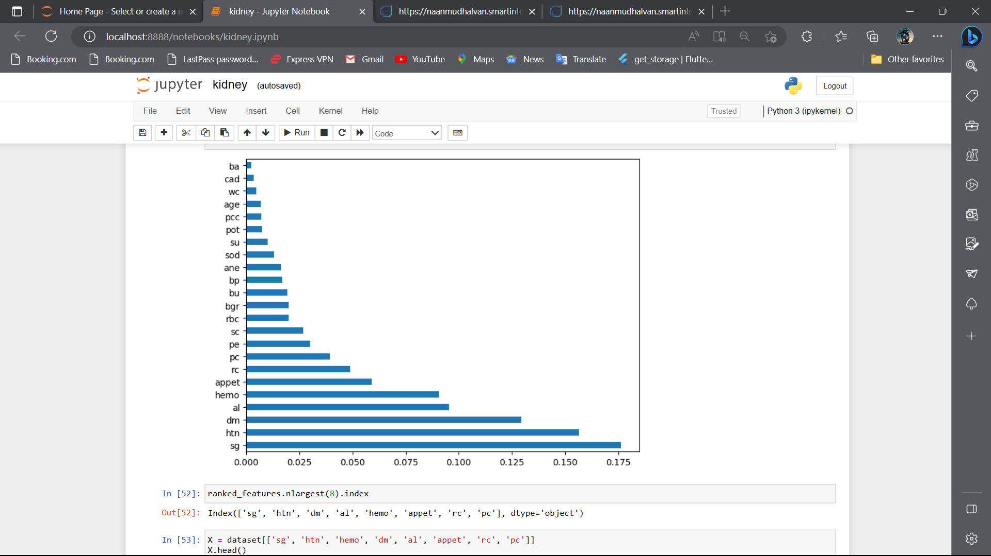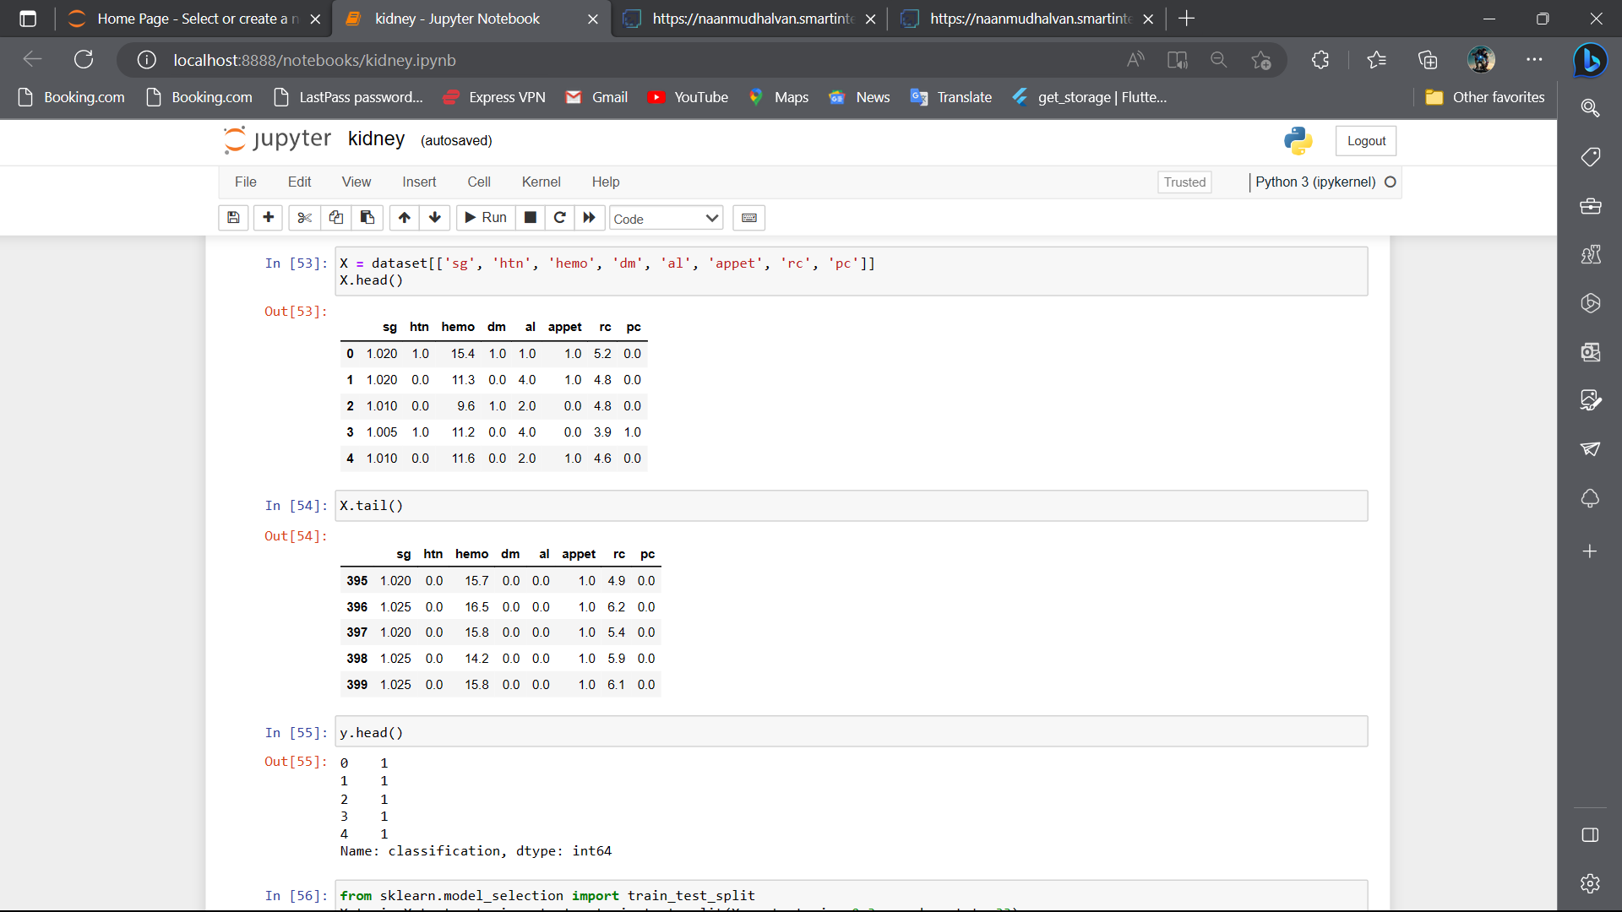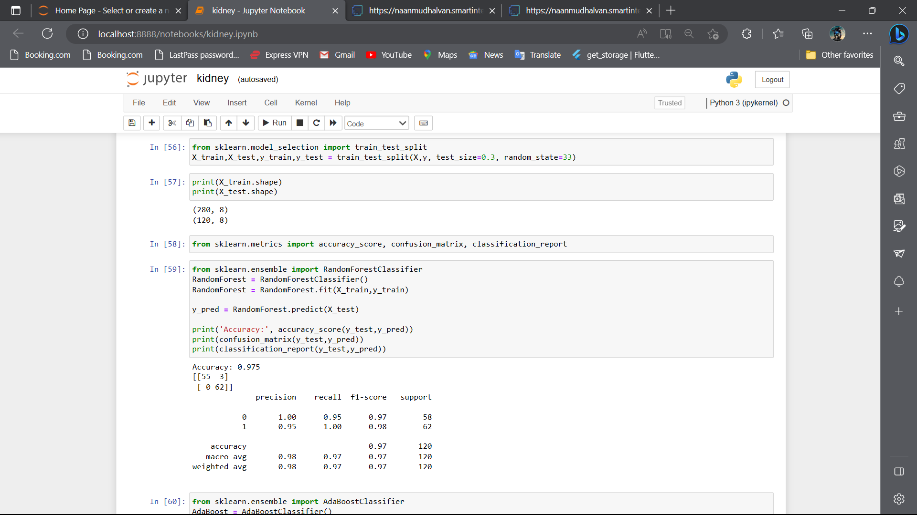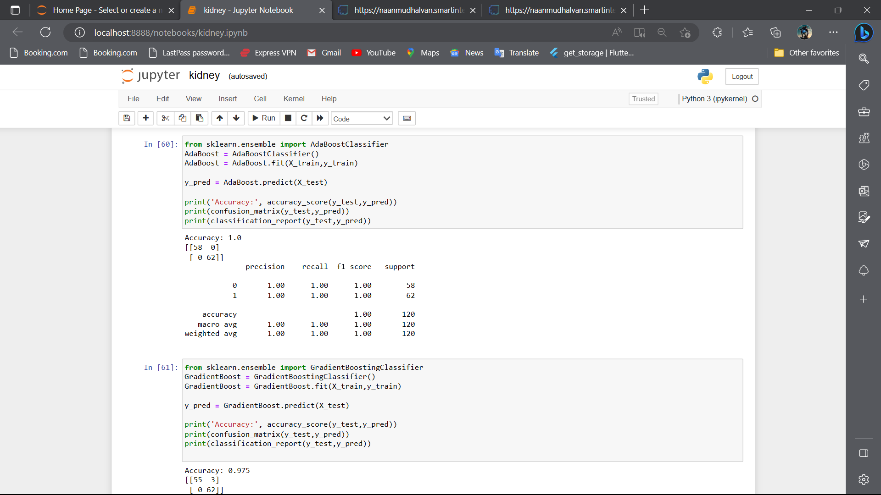

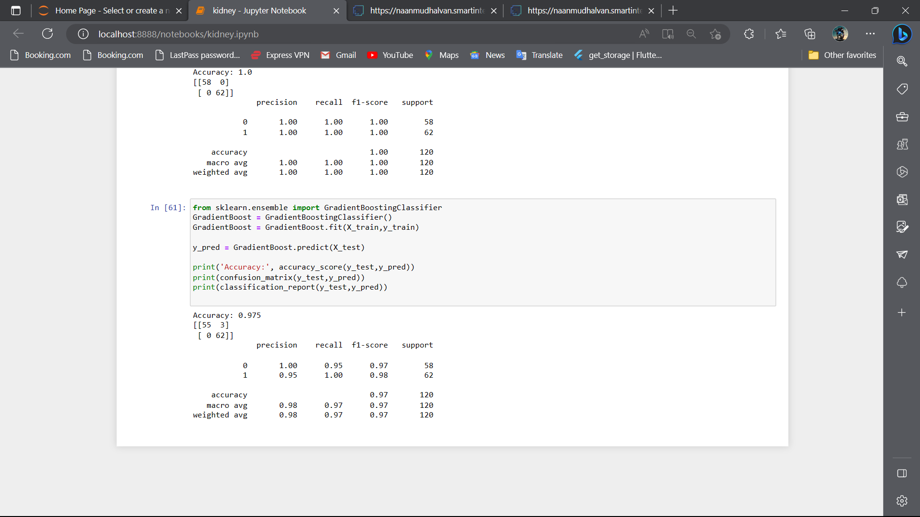

Result.html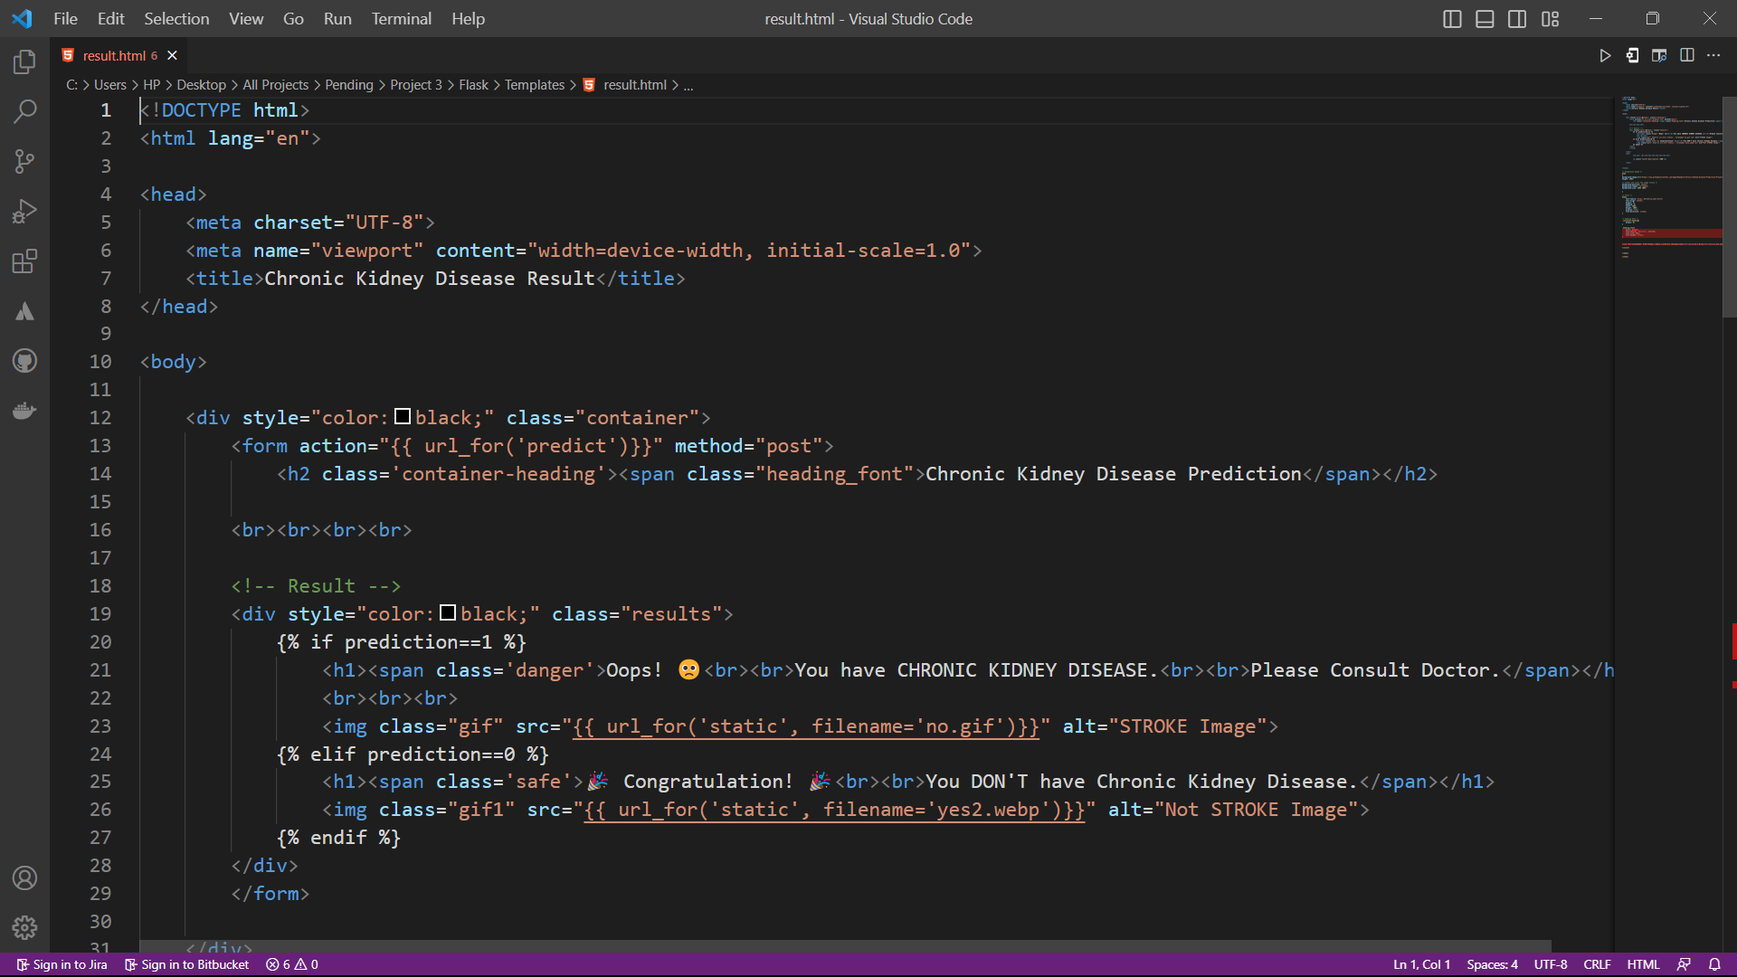





Index.html



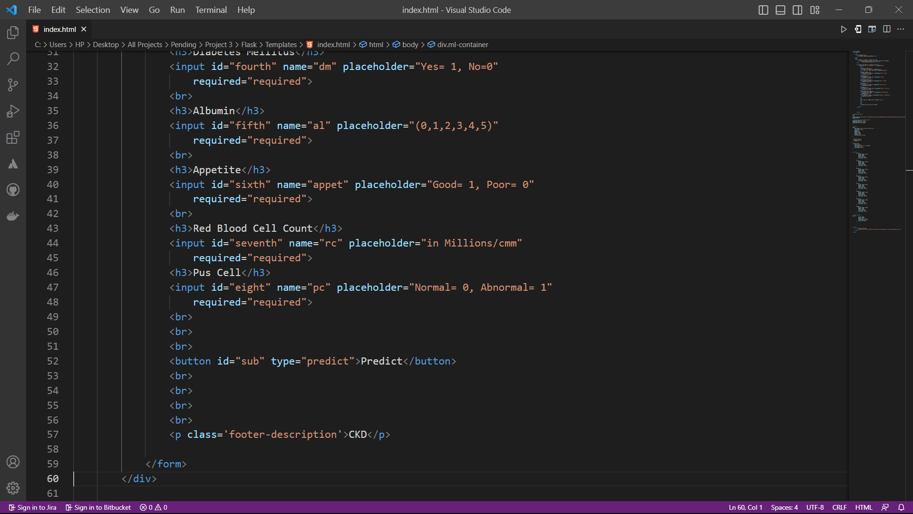









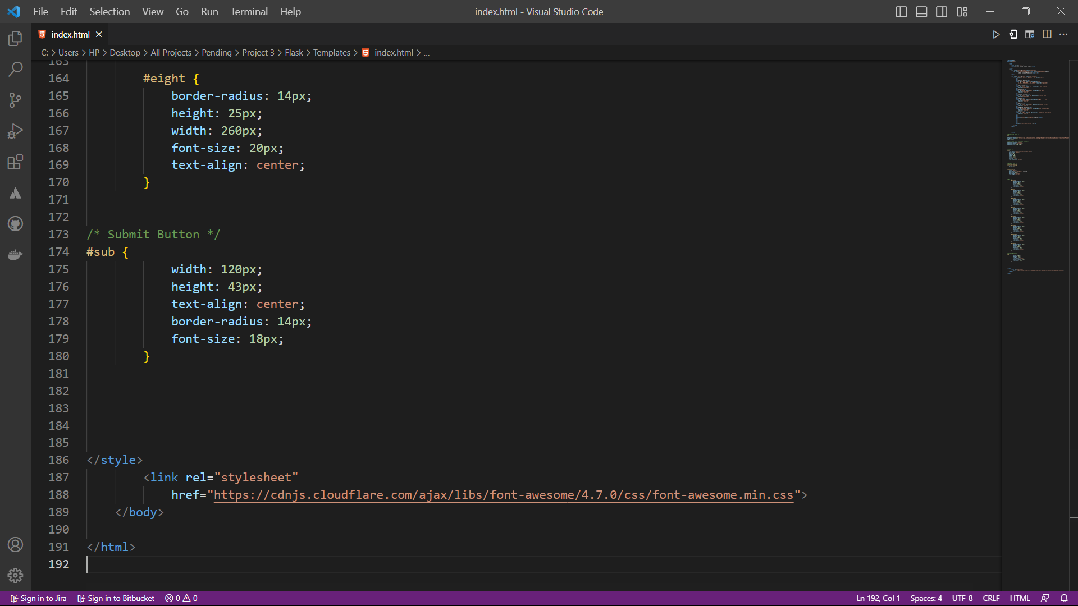

App.py

